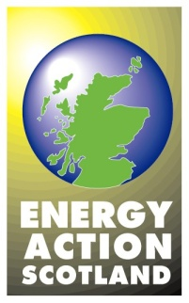

Tariffs

There is a range of tariffs available from each energy supplier. Suppliers may also offer ‘bundled’ products and rewards with tariffs. Bundled products might include things like boiler maintenance cover. Rewards might include things like supermarket shopping points. For example, customers might be offered nectar points for choosing a particular tariff, for providing regular meter readings or for referring. All tariffs have a standing charge and a single unit rate, however suppliers can set the standing charge at zero if they wish. Dual fuel and online account management discounts are also available and apply uniformly across all tariffs as £/pence per year.

Price comparison websites allow more accurate comparison of the tariffs available. It is best to use sites that have the Ofgem Confidence Code logo. The Ofgem list of approved sites that offer a free comparison and switching service for consumers is below. Many of these sites also offer a telephone service.
www.ukpower.co.uk www.uswitch.com
www.simplyswitch.com www.theenergyshop.com
www.unravelit.com www.moneysupermarket.com
www.switchgasandelectric.com www.runpathdigital.com
www.energylinx.co.uk www.energyhelpline.com
www.myutilitygenius.co.uk www.quotezone.co.uk

To ensure that comparisons are as accurate as possible; customers should have the following information to hand:
- name of current tariff
- details of previous electricity/gas use in kilowatt hours (preferably annual use)

Please note that some customers who have a specific tariff for electric storage heating (often referred to as a ‘time of use’ or off-peak tariff) may find it difficult to make accurate comparisons because few suppliers are able to offer like-for-like tariffs. Some time of use tariffs are not displayed on comparison sites. However there are a few that offer alternatives, also relevant suppliers must make all their single rate tariffs available to domestic customers on restricted tariffs/ meters.

Suppliers are required to give all their customers personalised information on the cheapest tariff they offer for them. This information appears on each bill/statement and on a range of other customer communications.

Suppliers also provide personalised estimates – a Personal Projection (PP) - which takes account of a customer's usage to enable them to compare tariffs more accurately when switching.

A tariff information label (TIL) on bills/statements sets out key terms and conditions for each tariff as well as relevant information to help consumers compare across suppliers.

