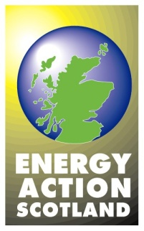

Home Energy Efficiency Programmes for Scotland (HEEPS)

In order to tackle fuel poverty and meet energy and emission reduction targets, a primary focus of the Scottish Government strategy is on improving the energy efficiency of Scotland's existing homes by retrofitting the existing housing stock. The Scottish Government’s Infrastructure and Investment Plan lists energy efficient homes as a national priority. HEEPS helps to maximise the measures and funding opportunities available to households across Scotland.

Scottish Government money is being used to bring together a range of funding streams and to lever maximum investment by the energy companies into Scotland, primarily via ECO (Energy Company Obligation).

Area Based Schemes

At the core of HEEPS are area-based schemes aimed at tackling fuel poverty. Responsibility for programme delivery falls to local authorities which are probably best placed, through their strategic role under the Local Housing Strategy (LHS), to understand the nature of housing provision across their area. Local authorities have the ability to facilitate access to information and services, acting as trusted local intermediaries. They are best-placed to enable effective local delivery (co-ordinating a local supply-chain) of a national programme. Local authorities will each develop and deliver their own programmes – mainly solid wall insulation – in areas of high fuel poverty.

Where a household does not qualify under the Energy Company Obligation then the Scottish Government programmes may provide support.

Area-based schemes are being delivered by local authorities. The Energy Saving Trust manages delivery of the other HEEPS schemes. To find out what measures are available in a particular area, contact the local authority or call Home Energy Scotland on 0808 808 2282.

