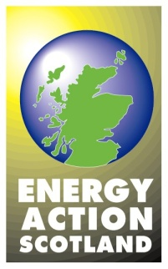
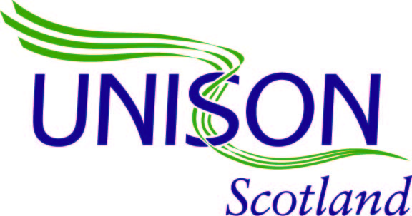

Home Energy Scotland Loan Scheme
Home Energy Scotland loans replace two previous programmes - the HEEPS Loan Scheme and the Home Energy Scotland Renewable Loan scheme.
The Home Energy Scotland Loan scheme is an interest free loan of up to £32,500 per home. It is available to owner occupiers and eligible private sector landlords (who can apply for up to 3 properties) for energy efficiency improvements, home renewables systems and connections to an approved renewables district heating scheme.
25% Cashback Offer
Households are eligible for a grant of 25% of the cost of energy efficiency works, up to a maximum of £3,750. Maximum loan value for energy efficiency measures is £15,000 including cashback. Please note, the cashback offer does not apply to loans for renewables systems or secondary improvements.

The repayment period varies based on the amount borrowed but those taking out higher value loans will be able to pay back over 12 years.
Applicants are responsible for ensuring that the installer chosen is fully qualified and accredited with a relevant industry body and/or trades federation. The applicant must have an acceptable energy report recommending the improvements to which the loan applies.
For more information contact Home Energy Scotland 0808 808 2282 http://www.energysavingtrust.org.uk/scotland/grants-loans/home-energy-scotland-loan
Scotland’s Energy Efficiency Programme (SEEP)
Equity Loan Scheme: A £10m scheme currently being piloted in Glasgow, Argyll and Bute and Perthshire. Home owners on low incomes in those areas can apply for an interest-free loan of up to £40,000 to help them make essential repairs to leaking roofs and building structures. This work is often necessary before energy efficiency measures like solid-wall insulation can be installed. The loan will be repaid when the property is sold.

