26 March 2018

To the Trade Union Side Joint Secretaries of the Scottish Joint Council

Dear Johanna, Willie and Drew

Scottish Joint Council Pay Claim 2018/19 – Employers Side Offer.

I am writing to advise you that on Friday, at a specially convened meeting of COSLA Leaders, the undernoted pay offer was agreed in response to the SJC Pay Claim 2018 as set out in your joint letter of 12 January, 2018.

Employers Side Pay Offer to the SJC

- The policy and aspiration to achieve parity of pay awards across the bargaining groups, in as far as it is within COSLA’s control, has been re-affirmed by COSLA Leaders and a uniform pay offer is being made to the entire workforce, across all four of the local government bargaining groups.

- The pay offer is for one year and covers the period 1 April, 2018 to 31 March, 2019. The award will be back dated to the 1 April, 2018 application date.

- The pay offer has been aligned, for the most part, to be consistent with public sector pay policy in Scotland and is based on a 37 hour working week viz:-
    - A 3% pay increase will apply to all employees earning up to £36,500.
    - A 2% pay increase will apply to all employees earning £36,501-£80,000
    - A flat rate increase of £1,600 to employees earning more than £80,000.

The pay offer deviates marginally from public sector pay policy in relation to the Living Wage. It is proposed to increase the ‘Scottish Local Government Living Wage’ from its present level of £8.51 per hour to £8.77 per hour, thereby providing a full 3% increase.

The offer also provides for a 3% increase on all allowances that are normally agreed through the SJC, with the exception of the First Aid Allowance, which is under separate discussion between the Employers and Trade Unions Sides of the SJC.

The pay offer is being made against a backdrop of a challenging settlement for local government and continued cost pressures for councils. No additional monies have been made available in the 2018/19 local government settlement for this pay award, consequently, COSLA Leaders have agreed that the offer now put to the various trade unions across the four bargaining groups is the best and final offer which can be made for this year.

I should be obliged if in receiving this pay offer from the Employers Side, you would undertake such steps as necessary to ascertain the views of your members and in due course provide COSLA Employers with your response.

Yours sincerely

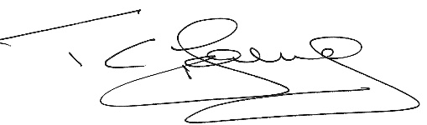

Tom Young
COSLA Employers Secretary

