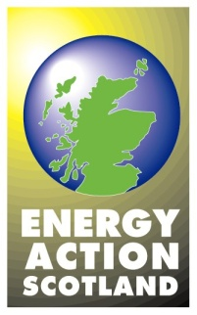
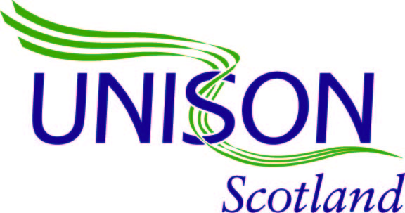

Regular Payment Schemes

Consumers may be able to pay for fuel in equal amounts every week, fortnight or month. Payment books are suitable for people without a bank account and can help with budgeting.

Quarterly statements are usually provided and show how much fuel has been used and how much has been paid.

At the end of 12 months, a ‘settlement’ notification is supplied to the customer. This will show either a credit (and a possible refund), or a shortfall and that money is owed to the supplier.

Advantages:
- Can help budgeting by spreading out payments evenly across the year

Disadvantages:
- If actual use is less than was estimated, the fuel company has the benefit of the extra money until the end of the twelve months – next year the customer can negotiate a reduced payment amount. Conversely, if actual use is more than estimated, a debt will accrue
- It relies on the customer being able to travel to payment outlets, such as a bank, Post Office or a PayPoint outlet, on a regular basis
- Travel costs need to be taken into consideration and there may be a surcharge to pay for using the payment book, making it more expensive than direct debit.

Not all fuel suppliers offer this form of payment.

This payment method suits:
- People without a bank account
- People who find it difficult to budget monthly or quarterly

