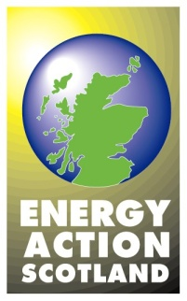

Struggling with fuel bills/debt

Customers who find themselves struggling to pay fuel bills/arrears should be encouraged to contact their supplier as soon as possible. The appropriate telephone number will be on the bill or annual statement. Contact numbers for the main suppliers are listed below.

ScottishPower 0800 027 0072 (from landline)
0345 270 0700 (from mobile)

British Gas 0333 202 9804
18001 0800 072 8626 - Textphone

SSE 0345 070 7395
0800 622 839 - Textphone

EDF Energy 0800 096 8628

E.ON 0345 301 5882

npower 0800 073 3000 (from landline)
0330 100 3000 (from mobile)
0800 413 016 - Textphone

With regard to arrears, energy suppliers have to follow certain rules when dealing with their customers. They should:
- give advice on how to pay back monies owed
- offer advice on reducing energy use
- offer a payment plan taking into account ability to pay
- set repayment rates taking into account ability to pay

Home Energy Scotland may be able to provide advice and information. Contact them on 0808 808 2282. They should also be able to provide additional information about other sources of help and support – local authority services, income maximisation/money advice, etc.

The Citizens Advice consumer service advises clients on a range of issues, including domestic energy. To use the Citizens Advice Consumer Service call 03454 040506

