J.Mooney@unison.co.uk

Humza Yousaf
Scottish Cabinet Secretary for Health and Social Care
Scottish Government

29 April 2022

Dear Humza,

Re: Social care workers mileage rates in third and private sectors.

With reference to your written answer to Jackie Bailley MSP in relation to her query about mileage rates for social care workers in the third and private sector, you referred her to a previous answer that you had given, reference S6W-07924.

In this answer you state that you had been in conversation with partners including local government on the impact increases in fuel prices have been having, and on how employers can support their staff.

UNISON understands from COSLA that there has been no engagement with you on the subject and that they were not sighted on the recent NHS agreement.

UNISON is concerned that once again social care workers in the third and private sector are being treated as the poor relations in Scottish public services. It’s inconceivable that the lowest paid workers are expected to shoulder the burden of increased fuel costs without assistance.

I urge you and your colleague Kevin Stewart, Minister for Mental Health and Wellbeing, to hold urgent talks with UNISON to discuss how we can support these essential workers.

There are more than 1,200 social care employers in Scotland. The Scottish Government must put mechanisms in place to ensure the issues that frontline staff have are adequately addressed to allow the continued delivery of essential services to the most vulnerable in society.

I look forward to hearing from you.

Yours sincerely,

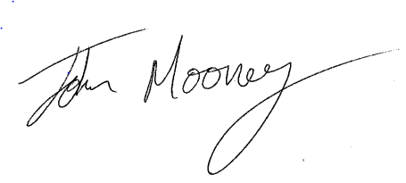
John Mooney
Head of Social Care

Cc Kevin Stewart, Minister for Mental Wellbeing and Social Care

