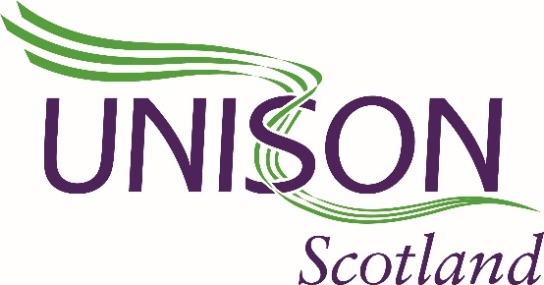
39 June 2022
Dear Councillor
NATIONAL CARE SERVICE
As Regional Secretary of UNISON Scotland, I want to ask you to use your position as democratically elected councillor to defend your council; its rights and its ability to deliver services for its people
There are aspects of the National Care Service which are welcome – the prospect of sectoral bargaining for social care staff in the private and voluntary sectors, will help address the chronic low pay and poor conditions of employment, and off the back of that the recruitment and retention crisis in care. This however does not mean that the negative features of the bill should be ignored.
• Under the new National Care Service Bill responsibility for provision of care and social work services will be stripped from councils and centralised with the Scottish Government. They will appoint a quango to administer delivery.
• There is no guarantee that the new care boards will be based on council boundaries as current IJB’s are, nor a guaranteed role for councillors. The number of boards and their members will be decided by the Scottish Government, after the bill has passed.
• Statutory responsibility for social care and social work are to be removed from your council. Adult services will transfer immediately, while ministers can then remove children’s services and justice social work functions whenever they choose. If this happens, this is effectively the end of local democratic control of social services. Local authorities are reduced to being contractors in a market.
This weakens accountability for service users. Instead of going to you as their local councillor, there will be a complaints process, much as people have with an energy provider. Accountability is focused upwards, to Scottish Ministers, not downwards to the people who receive care.
• The Bill assumes transfers of huge numbers of staff out of local authority employment. The financial memorandum for the Bill includes estimates for all social care and social work staff to transfer - that’s around 75 000 people. Our concern is that staff will only remain directly employed if the council wins contracts and commissions from care boards against third sector and commercial competition. We do not believe that social care and social work staff deserve this treatment.
It is time to take the profit out of care, not services from councils. Care should be delivered in and for the community. We believe that is what most people want and expect from a National Care Service.
We are asking you to stand up for publicly run and delivered social services, and against this attack on local democracy. UNISON members in your Council will be campaigning for social care and social work to be publicly run and delivered local services. We hope they can count on your support.
Tracey Dalling
Scottish Regional Secretary

